**APPENDIX**

**APPENDIX 1**

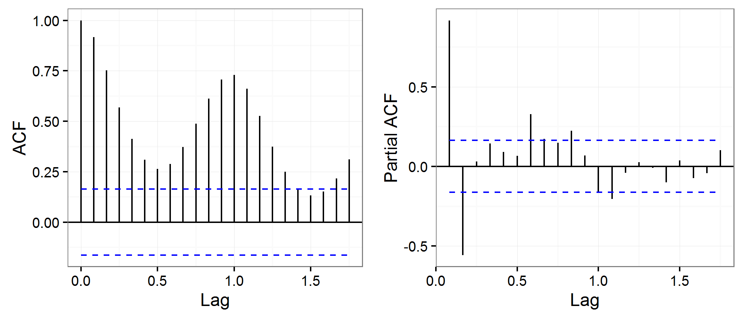

**Figure 8:** Autocorrelation and partial autocorrelation plots for salmonellosis time series (2011-2012)

**APPENDIX 2**

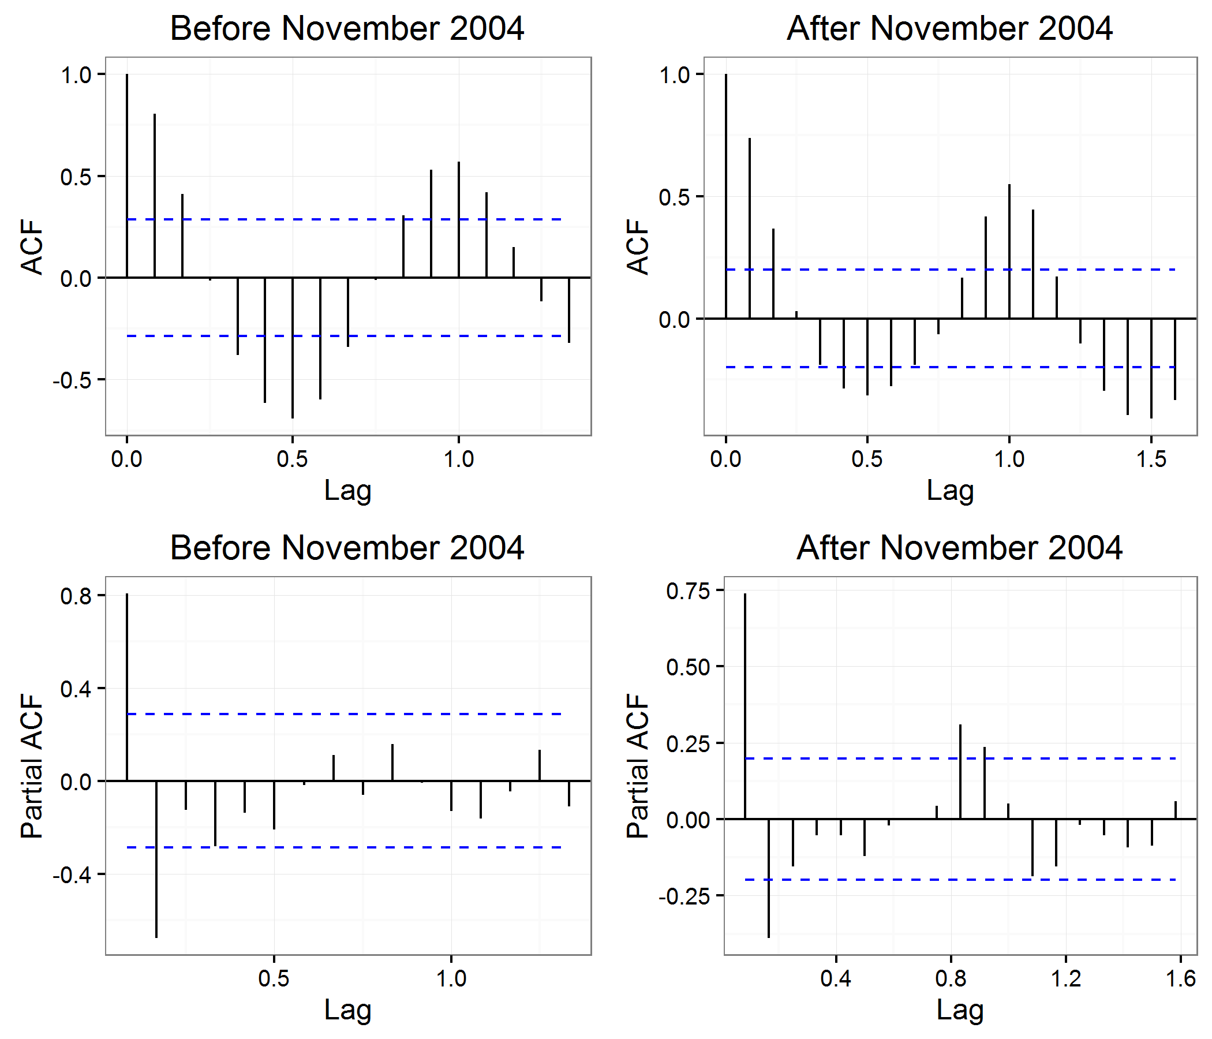

**Figure 9:** Autocorrelation and partial autocorrelation plots for salmonellosis time series before and after November 2004

**APPENDIX 3**

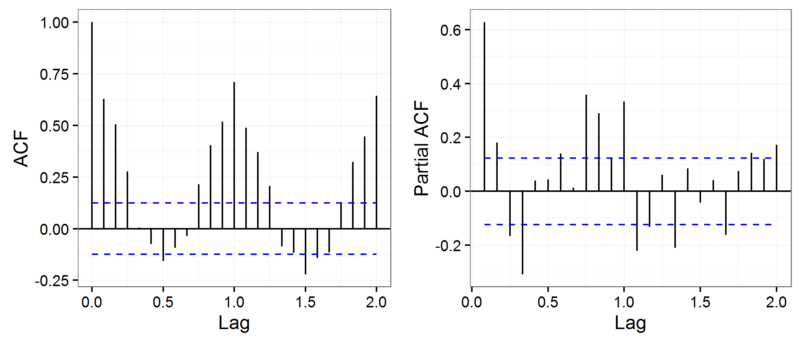

**Figure 10**: Autocorrelation and partial autocorrelation plots for campylobacteriosis time series

**APPENDIX 4**

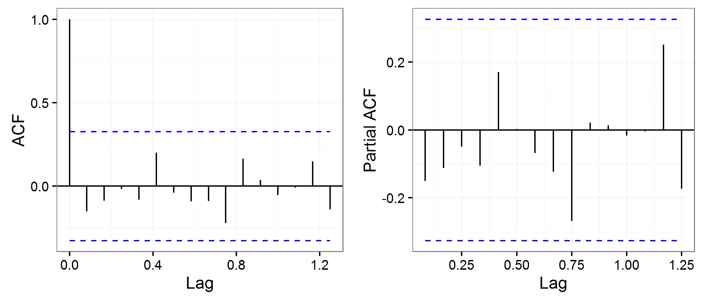

**Figure 11**: Autocorrelation and partial autocorrelation plots for listeriosis time series

**APPENDIX 5**

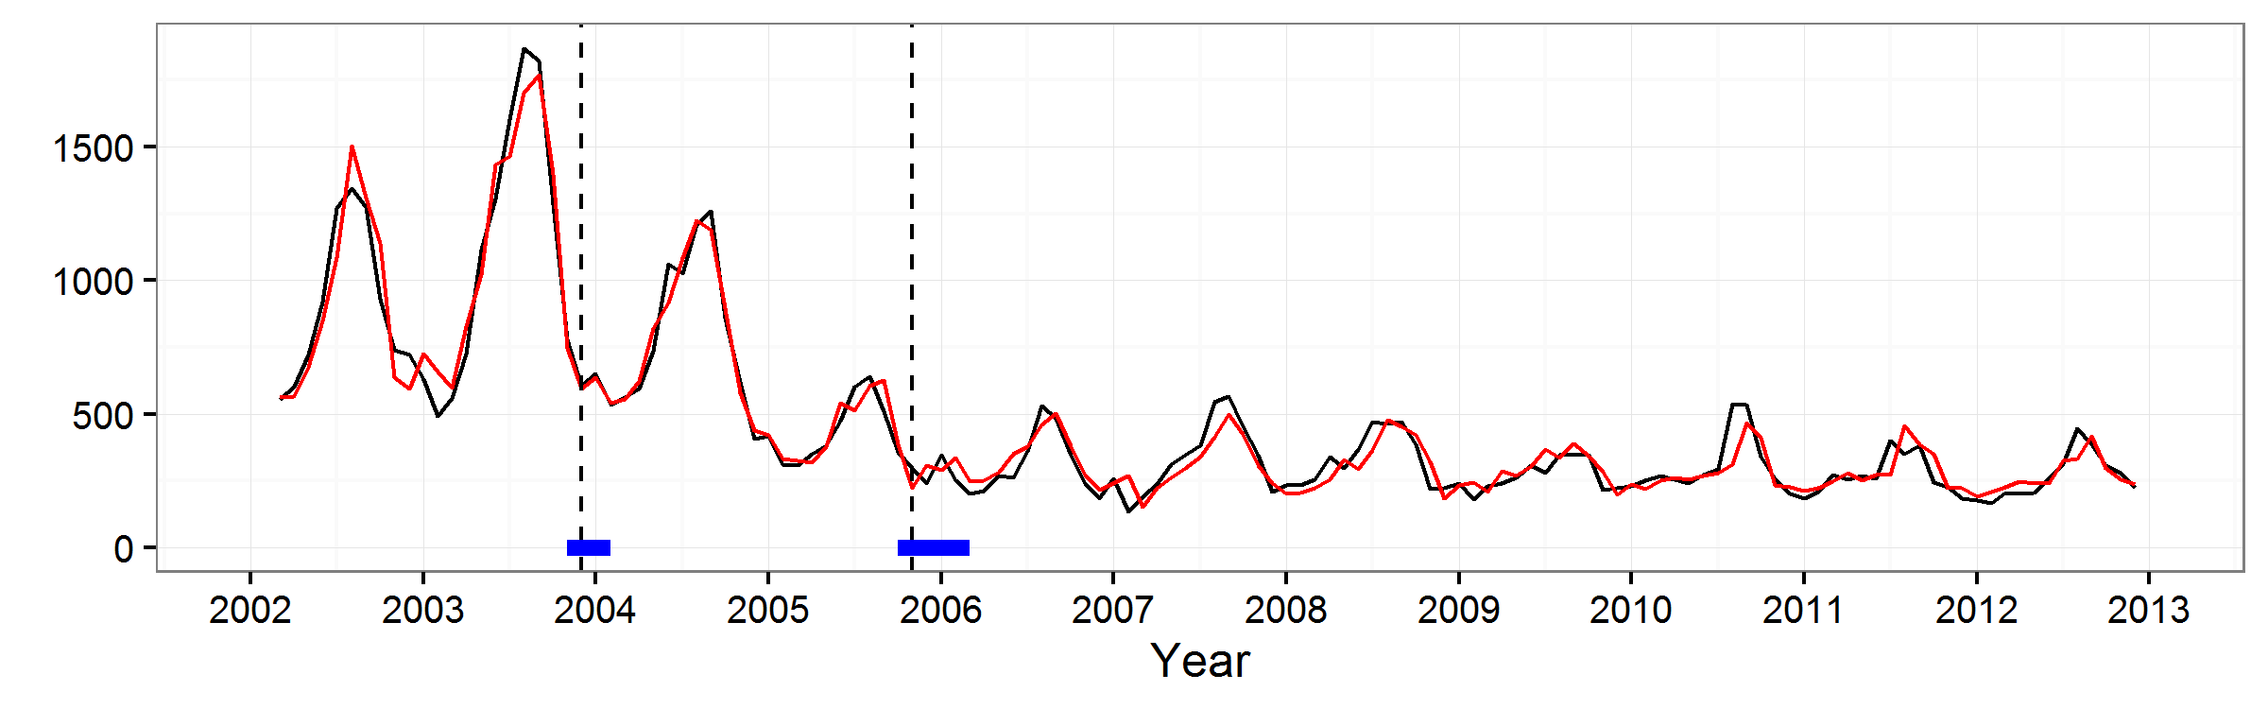

**Figure 12:** Observed salmonellosis time-series (black line) and modelled time series (red line)

**APPENDIX 6: Sensitivity analysis of the Disability-Adjusted Life Years for salmonellosis, campylobacteriosis and listeriosis in Belgium in 2012**

|  |  |  |  |  |  |
| --- | --- | --- | --- | --- | --- |
| Scenario DALYs | Methods | Salmonellosis  mean DALY 2012 (95% UI) | Campylobacteriosis mean DALY 2012 (95% UI) | Perinatal listeriosis  mean DALY 2012 (95% UI) | Acquired listeriosis mean DALY 2012 (95% UI) |
| Reported cases in 2012 in B* URF Belgium (Reference) | 1000 simulations drawn from the model described by *Havelaar et al. in 2013*.: 3.5 (95% UI: 0.3-11.3) | 102 (8 - 376) | 1019 (137-3181) | 269 (208-347) | 208 (192-226) |
| Reported cases in 2012 in B* URF France | 1000 simulations drawn from the model described by *Havelaar et al. in 2013*: 27.8 (95% UI: 3.9-82.2) | 779 (85 -2844) (+664%) |  |  |  |
| Reported cases in 2012 in B* URF Netherlands | 1000 simulations drawn from the model described by *Havelaar et al. in 2013* : 25.4 (95% UI: 3.7-85.5) | 768 (82 - 2697) (+653%) |  |  |  |
| Reported cases in 2012 in B* URF Germany | PERT (2.1; 8.7; 26.8)  *(Plass et al., 2014)* | 311 (69-776) (+203%) |  |  |  |
| Reported cases in 2012 in B* URF Canada | 1.1 (No uncertainty available)  *(Thomas et al., 2013)* |  |  | 296 (229-382) (+10%) | 229 (211-249) (+10%) |
| Reported cases in 2012 in B* URF Belgium + IBS as sequela | DW = 0.062 (95% CI 0.05-0.077) (*Haagsma et al., 2015*), Proportion of IBS = 3.3% (95% CI 1.6-6.6)  (*Keithlin et al., 2014*)  , Duration = 5 years (*Haagsma et al., 2010*), Age-dist (same as incidence) | 211 (17-733) (+107%) | 1357 (326-3607) (+33%) |  |  |
| Reported cases in 2012 in B* URF France + IBS as sequela | DW = 0.062 (95% CI 0.05-0.077) (*Haagsma et al., 2015*) , Proportion of IBS = 3.3% (95%CI 1.6-6.6)  (*Keithlin et al., 2014*)  , Duration = 5 years (*Haagsma et al., 2010*), Age-dist (same as incidence) | 1603 (216-5051) (+1472%) |  |  |  |
| Reported cases in 2012 in B* URF Netherlands + IBS as sequela | DW = 0.062 (95% CI 0.05-0.077) (*Haagsma et al., 2015*) , Proportion of IBS = 3.3% (95%CI 1.6-6.6)  (*Keithlin et al., 2014*)  , Duration = 5 years (*Haagsma et al., 2010*), Age-dist (same as incidence) | 1587 (189-5173) (+1456%) |  |  |  |
| Reported cases in 2012 in B* URF Germany + IBS as sequela | DW = 0.062 (95% CI 0.05-0.077) (*Haagsma et al., 2015*) , Proportion of IBS = 3.3% (95%CI 1.6-6.6)  (*Keithlin et al., 2014*)  , Duration = 5 years (*Haagsma et al., 2010*), Age-dist (same as incidence) | 650 (182-1431) (+537%) |  |  |  |
| UR = Underreporting factor |  |  |  |  |  |
| IBS = Irritable Bowel Syndrome |  |  |  |  |  |
| B = Belgium |  |  |  |  |  |